**Using the NanoVNA**

**Calibrating the NanoVNA**

1. Turn the NanoVNA switch on, the screen should populate. After it loads the BIOS and finishes booting, you will see weird looking lines everywhere on a grid.
2. Look for the 3 metal calibration connectors that were included.
3. Connect the included **OPEN** calibration cap to the S11/Port 1 port (when looking at the screen, the top left port. The open calibration cap is the all-gold one with **NO** center conductor. Screw it on until it stops, being careful not to over-tighten. It just needs to be on snug, not tight. This cap ensures no signals can enter the S11 port for this test.
4. Use the attached “guitar pick” as a stylus and click anywhere on the screen.
5. A menu will pop-up on the right side of the screen
6. Click **Calibrate**, then select **Calibrate** from the next menu as well.
7. Click the **Open** button to calibrate the device with no input (0% return).
8. The **OPEN** button will now have a checked checkbox to indicate it has set this calibration.
9. The selection will automatically advance to the SHORT test button.
10. Connect the included **SHORT** connector to the S11/Port 1 port (same port as before). The **SHORT** cap is the all-gold one with a center that is also gold and part of the cap. Screw it on, and gently push the cap in a little to make sure the floating center pin is seated well.
11. Click the **SHORT** button to calibrate the device with a shorted input (100% return).
12. The **SHORT** button will change to have a checked checkbox to indicate it has set this calibration.
13. The selection will automatically advance to the LOAD test button.
14. Connect the included 50-ohm connector to the S11/Port 1 port (same as before). The 50-ohm cap is the one that is **Silver AND Gold**, with a center conductor. Screw it on, and gently push the cap in a little to make sure the floating center pin is seated well.
15. Click the **LOAD** button to calibrate it with a load. The menu will advance to **ISOLN** (Isolation) test – we don’t need to do any additional calibration at this point, so click **Done** and then click anywhere on the screen to exit the menus.

**Install NanoVNA Saver**

<https://github.com/NanoVNA-Saver/nanovna-saver/releases>

Connect the NanoVNA to your computer via USB-C to USB-A cord then turn the NanoVNA’s power switch on. The NanoVNA screen should populate.

Open the NanoVNA Saver program that you installed earlier.

It will start with a command line window which stays open while you are using NanoVNA Saver. You can ignore any errors in the command line section for now, just leave it open.

Once it launches the GUI, look at the bottom left for the Serial Port Control section.

It will **USUALLY** list the correct serial port automatically. If not, you can select it manually from the drop-down, or click the Rescan button to let it try to find it.

Once the correct port is selected, click the Connect to device button. That button should now say Disconnect on that button.

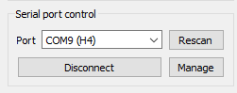

**Sweep Settings**

You will see default values under Sweep Control or 50KHz to 900MHz, which are basically worthless. Don’t worry about this for now, we’ll change them later.

**(Caveat – NanoVNA Saver is kind of a POS, so it crashes often. If it crashes, try restarting the program. If it keeps crashing, try power-cycling the NanoVNA)**

Connect the SMA to UHF adapter to the S11 port on the NanoVNA

Connect the UHF end to the antenna you wish to test (antenna only, no other devices connected).

Click **Sweep Setting** at the top under **Sweep Control**

Select **Averaged Sweep**

**Logarithmic Sweep**

**Number or measurements to average = 5**

**Number to discard – 2**

**Select Band**: Select any band you want, for antenna tuning we will start with a full range sweep so it doesn’t really matter what you select here, we will be changing it anyway manually later.

**Pad limits set to 10%**

Click **Set band sweep** button at the bottom. The window will NOT go away, and the only change you will see is that the Sweep Control section at the top left now has different values than before.

Now that we have our other parameters set, you can close the Sweep Settings window manually.

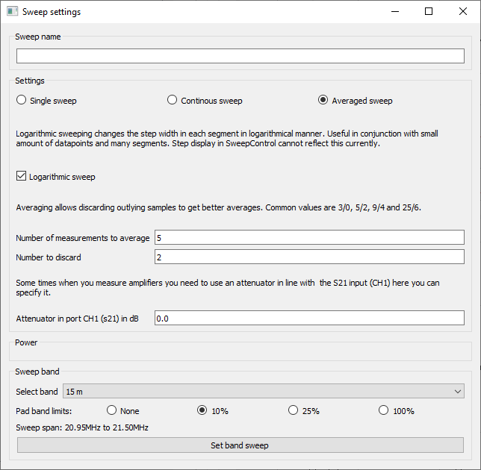

**Display Setup**

Click on the button labeled **Display Setup** at the bottom left

Look under **VSWR Markers** and use the drop-down list to see what values are already there.

If you do not have the following values, use the **Add** button to add them. 1.25, 1.5, 2.0, 2.5, 3.0

The **Add VSWR** window will pop-up and allow you to add additional values.

After entering a value, click the **OK** button to add it. To add more, repeat the 2 steps above until they are all added. This step will draw SWR lines in the chart so you can more easily see where your antenna is resonant.

Once you have added all the VSWR markers, you need to make sure the **Show Bands** option is checked in the **Bands** section of the main **Display Settings** window. This will make gray lines appear for the pre-defined Radio Bands within the sweep, which is helpful.

Change all other settings to those visible in the picture below.

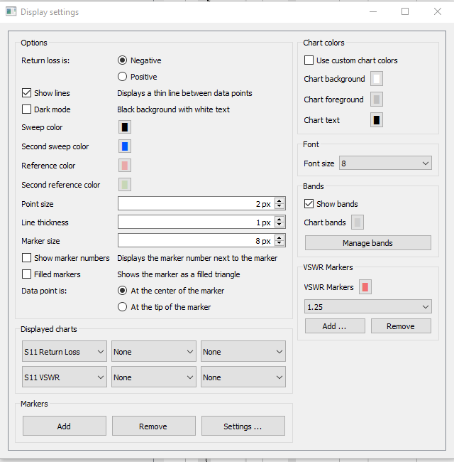

Once complete, simply **close** the window to save the settings.

**Conducting a Sweep**

Since we want to know what a EFHW Multiband antenna will do, we need to sweep more than one band’s range.

At the top left, change the Sweep Control Start setting to read 3.0MHz (you can simply press 3m and it will know you mean 3.0 MHz) and Stop to be 30M. You always want the start and stop frequency to be slightly lower and higher than the range of the band so you have some space on each side of the chart.

Click the **Sweep** button (Not Sweep Settings) to execute a frequency sweep.

You will see the progress bar move in 20% increments (we are doing 5 sweeps) until it reaches 100%, you can now see the SWR of the antenna across it’s spectrum of use.

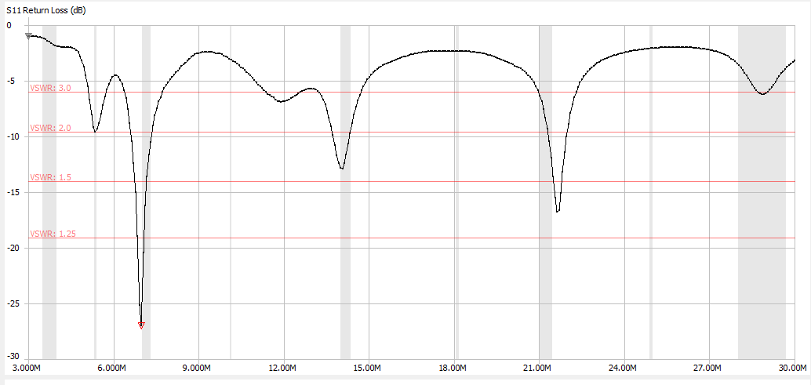

In the chart above (my current antenna), you can see the 4 horizontal red lines that we setup earlier to show us the SWR readings. You can also see the gray vertical lines that highlight the bands within that sweep range (3.5MHz/80M, 5.3MHz/60M, 7MHz/40M, 14MHz/20M, 18MHz/17M, 21MHz/15M, 24MHz/12M, 28MHz/10M). In the chart above, you can see that almost none of the bands are tuned perfectly on the antenna. But overall, it’s close on the bands most hams really care about, 40M, 20M 15M, 10M. When the dip happens before the band line, it means your antenna needs to be shortened to move the line to the right. If it is after the band line, you need to lengthen the antenna to move the dip to the left. We want to keep everything under 3:1 SWR to be usable.

Luckily, I have a tuner, so I can get away with things as they are now for the 10M and 15M bands. The 40/20M are under 2:1 SWR, and the 15M is right at 3:1 SWR. You can build the EFHW with loading coils to pick up the 80M band, but I have not yet done so. You can also insert band filters in the line to make the 10/15M “see” a shorter wavelength, but again, I have not yet done this aside from building the filters.

To quickly see what SWR’s you are dealing with, you can run an Analysis. Click the **Analysis** button at the bottom left just under all the readings, and select the settings you want to use. In the example below, you will see the **Start** and **End** frequencies for the VSWR limit you set, the **Minimum** (resonant frequency) and the **Span** that is under the VSWR limit you set.

For this example the 40M band has a 3:1 SWR or less from 6.44250 MHz to 7.72500 MHz, which gives us a span of 1.28250 MHz, and a resonant frequency of 6.98250 MHz, whose SWR reading is 1.09.

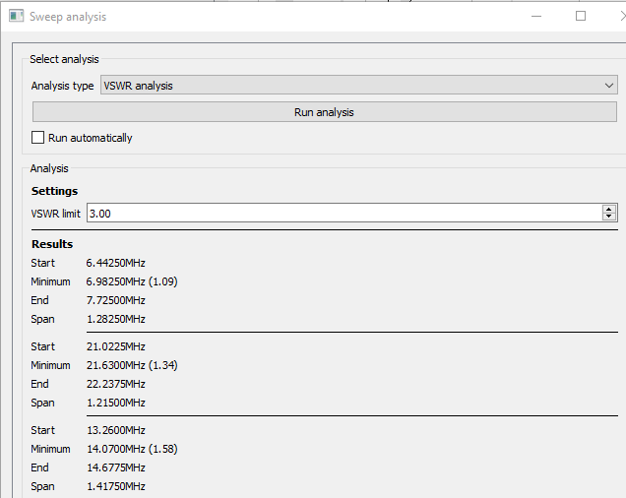

When I have to trim my antenna, I usually find out what my resonant frequency is currently, so I don’t have to guess how much I need to trim, but instead have a S.W.A.G. to start from. To find the resonant frequency just place a marker at the lowest point of the wave for the band you want and read the Marker 1 section on the readout for the Frequency that is at that marker you set (the little red triangle at 6.9MHz above).

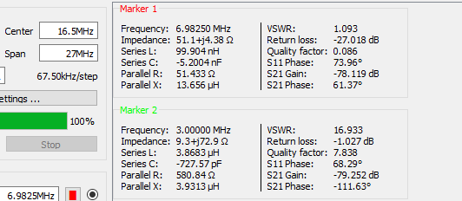

In this example, the antenna is performing best at 6.98250 MHz. If I want to tune it to 7.1500 MHz (center of the 40M band) you would need to find the length for both frequencies in feet, then subtract the difference to know how much you need to remove. To find the length in feet we divide 468 by the frequency.

468 / 7.150 MHz = 65.4545 feet

468 / 6.9825 MHz = 67.0247 feet

Difference is 1.570 feet – so I would try folding back around 1.5 feet and winding it around the main wire and test again. If it was perfect (or close to it) I would trim a little under that amount from the winding and test again and again as I slowly cut an inch or so at a time to creep up on the perfect match.

For the example above, I am not making any cuts since the 15M band (which I use often during the day) is a little short already, which is why I split the difference to get a good all-around coverage antenna.

Also keep in mind the wire is tinned copper, not steel or Kevlar reinforced, so it will stretch over time, and it will be slightly longer in hot weather, and slightly shorter in the cold.

If you make any adjustments or changes (angle of the slope, distance to ground, etc.) to retest all you have to do is click the Sweep button to run the tests again. If you want to retain the first reading to see how much of a change there is, before running the sweep again, click the Set current as reference button towards the bottom left before you run it again. It will show you your reference reading every time from then on as well as the current reading so you can see the overall difference.

If you want to save the results for later use, simply click the Files button (bottom left) and select **Save 1-Port file (S1P)** and give it a meaningful name (e.g. 20230429_EFHW_10152040_post_trim.s1p or whatever tells you what it is a sweep or reference for. You can load that file later by selecting **Files** > **Load as sweep** or **Load reference**.

